Website is

<https://optum.service-now.com/>

Select change

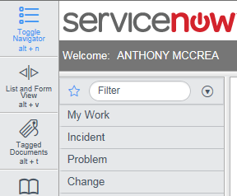

Select



Enter template CHG0030233 into the find template field

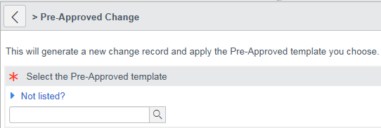

Hit submit!

Notes

Search for your name in 2 places and hit enter add the workgroup in Pat’s e-mail 

You must save now

Then enter the dates and times you want the control open for

Enter this note into Core hours explanation field “All changes are required to be made during business hours in order to validate production changes are completed correctly”

Go to Affected CI’s and Hit edit

Search for undefined software and add it and save

Go to Undefined CI Detail and hit new

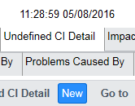

Hit new in Undefined CI Detail and Add VCCD Node 5 and save

Go to the top and hit submit approval and save and should be done

To close hit Close enter the start and finish times and select implemented as planned and save.